ECA18 - Optoelectronics and Optical Communication
Experiment No : 17
EYE DIAGRAM ANALYSIS OF OPTICAL COMMUNICATION LINK USING OPTISYSTEM

OBJECTIVES
1. Design and establish a fiber optic communication link using OptiSystem
software.
2. Measure and evaluate the Bit Error Rate (BER) of the system for different fiber
lengths.
3. Study the effect of fiber length on BER, Q-factor, a=enuation, and dispersion.

SOFTWARE REQUIRED
• Optisystem software

EXPERIMENT PROCEDURE
1. Open OptiSystem and create a new project.
2. Add a PRBS Generator as the data source.
3. Connect the PRBS Generator to an NRZ Pulse Generator.
4. Add a CW Laser Source for optical transmission.
5. Connect the laser output to the optical fiber.
6. Set the transmiser parameters such as wavelength, bit rate, and optical power.
7. Set the optical fiber length according to the required test case.
8. Keep asenuation and dispersion values as specified in the fiber parameters.
9. Connect a PIN Photodetector at the receiver.
10. Add a Low Pass Filter and 3R Regenerator after the photodetector.
11. Connect a BER Analyzer to the receiver output.
12. Run the simulation for each fiber length.
13. Observe the BER, Q-factor, and Eye Diagram.
14. Compare the performance for different fiber lengths.
15. Save the results and conclude the experiment.
OUTPUT :

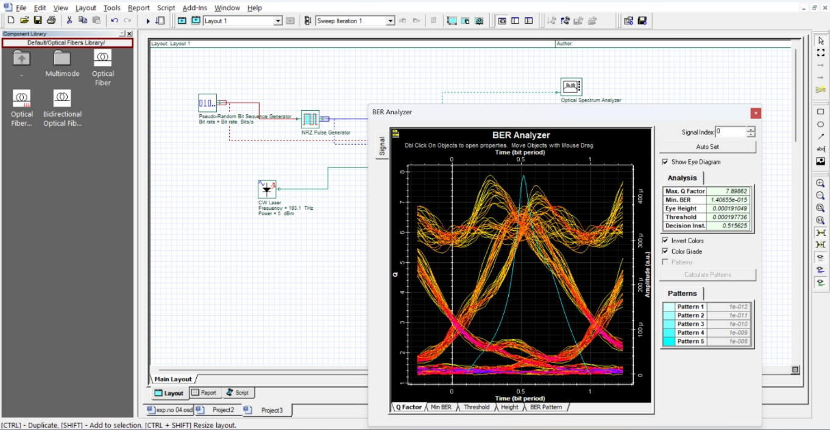

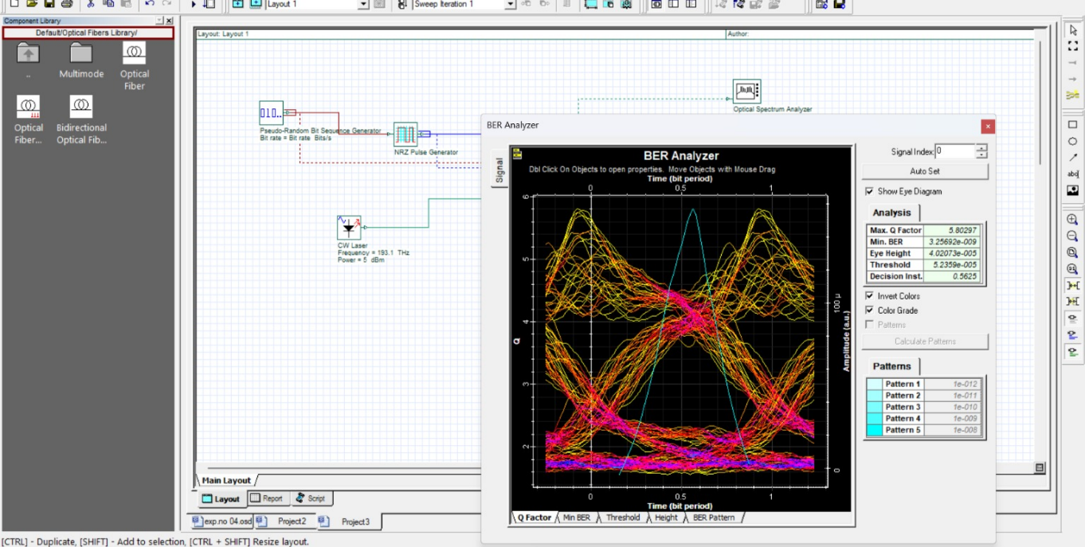

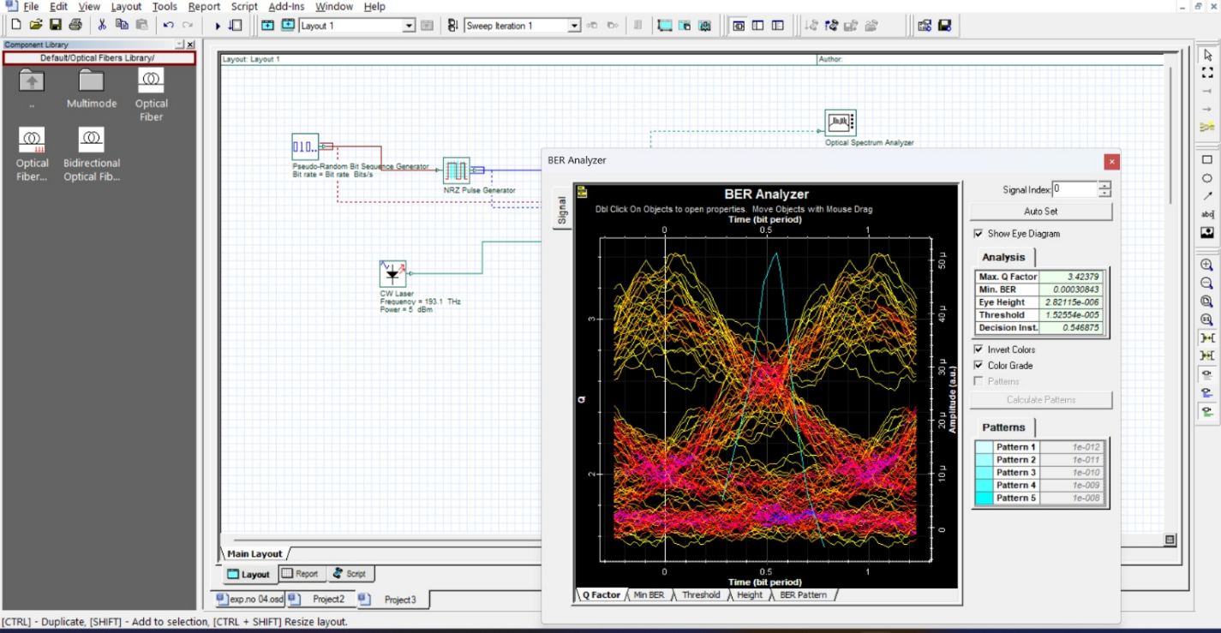

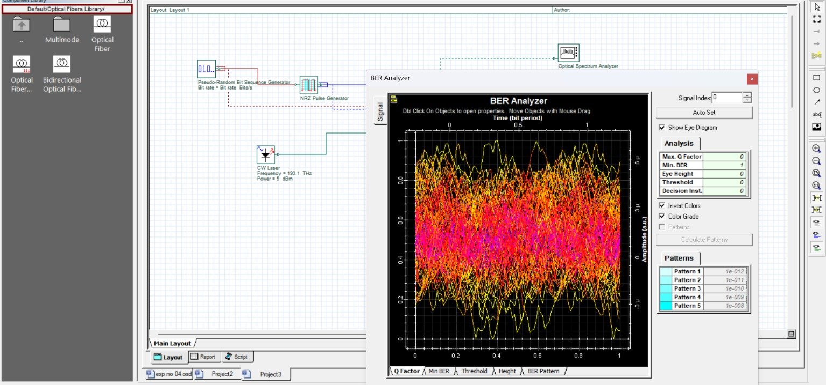

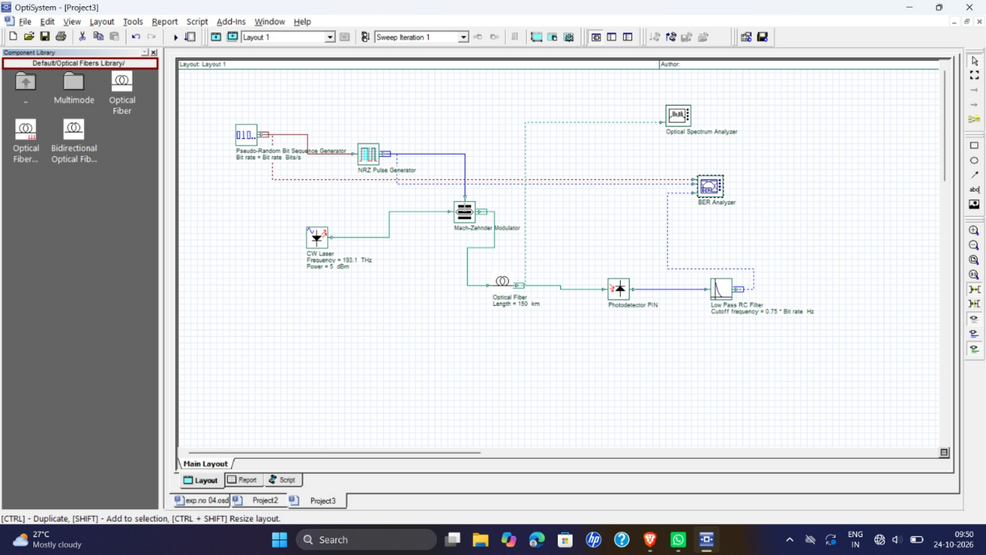

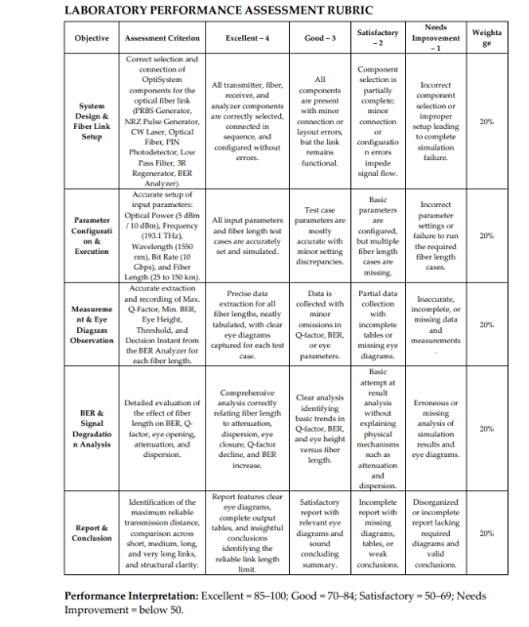
RESULT
The eye diagram of the optical communication link was analyzed using OptiSystem. The eye opening was used to evaluate signal quality, noise, intersymbol interference (ISI), and the performance of the communication system.

REFLECTION
This experiment helped me understand how an eye diagram is used to analyze optical communication link performance. I learned that a wider eye opening indicates better signal quality, while a closed eye indicates increased noise and intersymbol interference.

